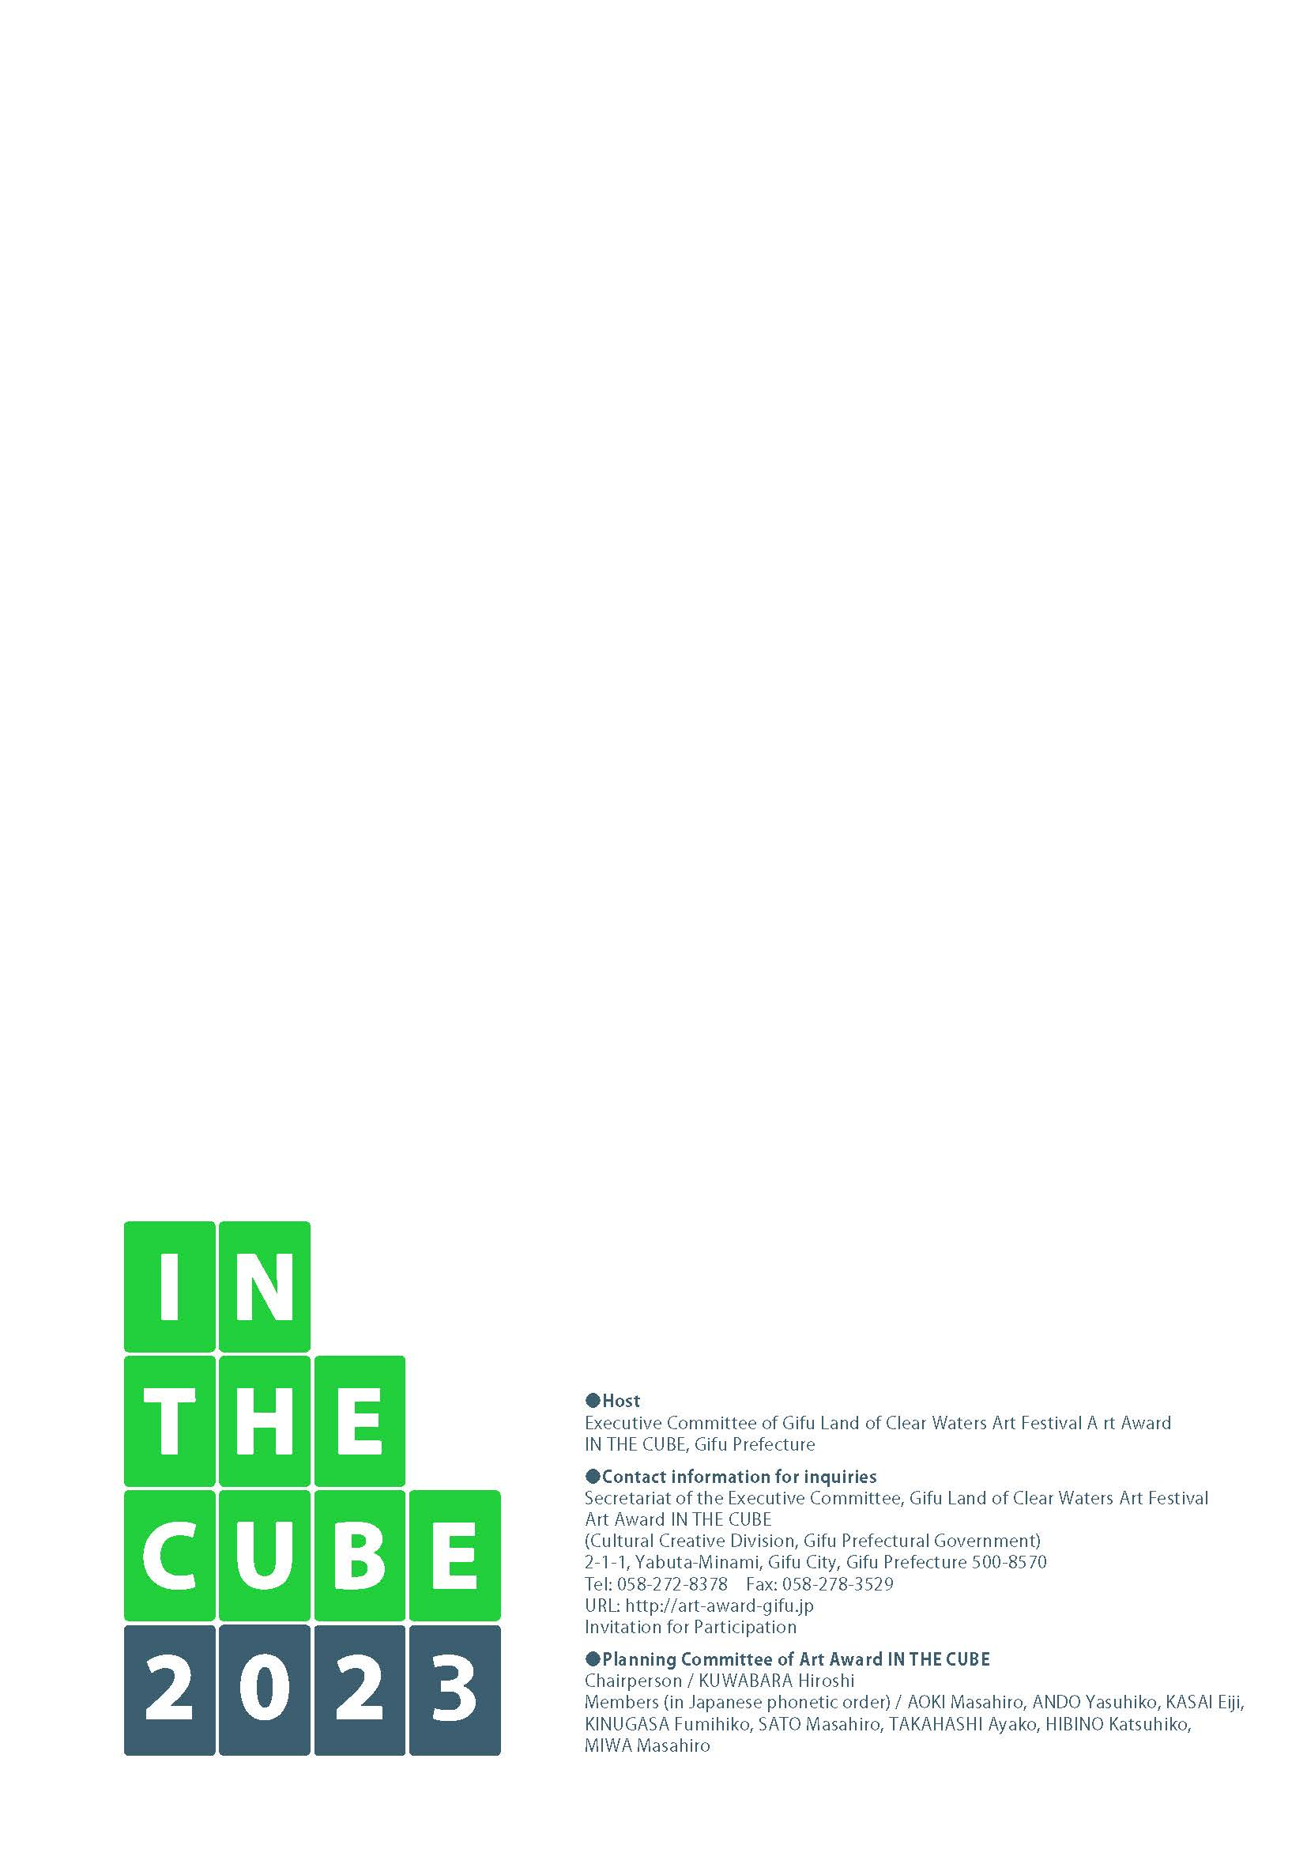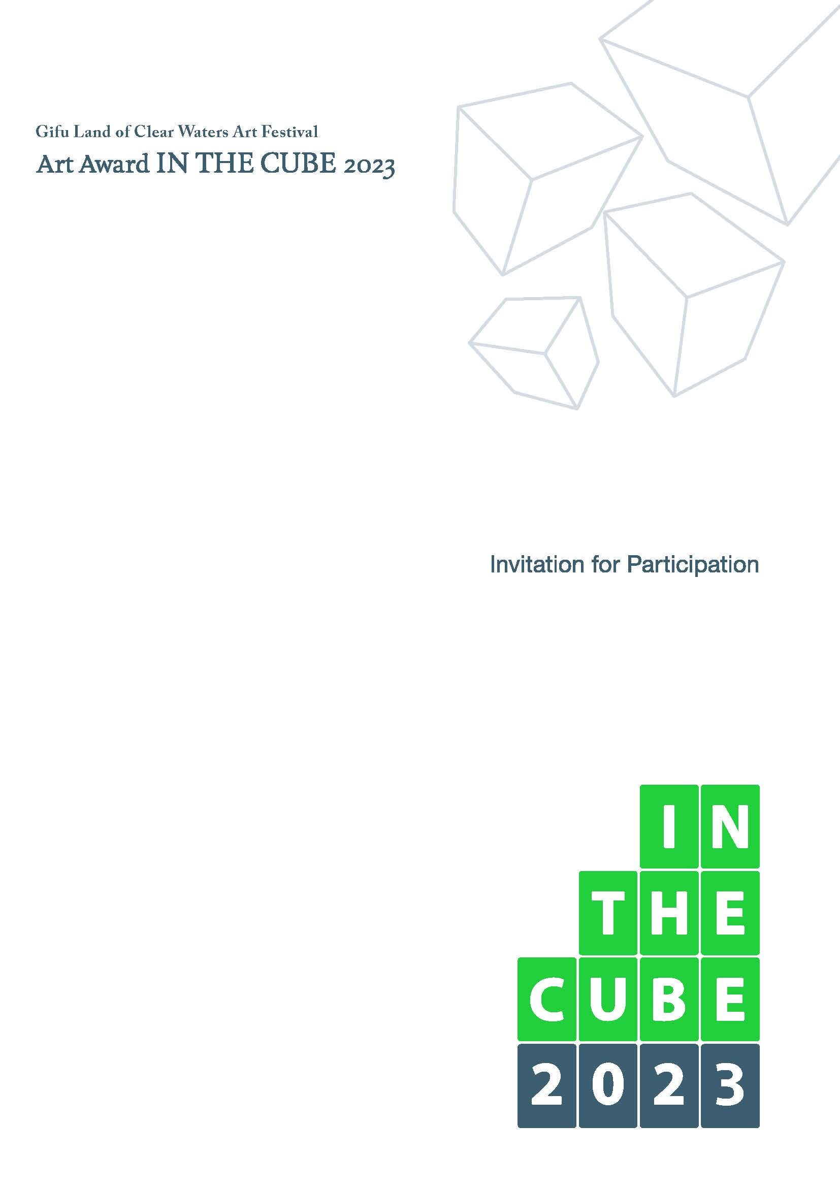

What is the Art Award IN THE CUBE 2023?
What is the Art Award IN THE CUBE 2023? ｜ Theme

Theme “REAL” no yukue

(“Where ‘REALITY’ Goes”)

*1: Legend says that the Buddha was ichi- jo-roku-shaku, or approximately 4.8 m, tall. For this reason, some statues of the Buddha were created in joroku size. For this exhibition, we adopted joroku as the size of the cubicle, inspired by the theme of AAIC 2017, “Shintai no Yukue (Whereabouts of the Body).”
Gifu Prefecture has been blessed with abundant nature since ancient times. Pristine waters originating from forests run throughout the prefecture. They have fostered master craftsmanship in ceramics in Tono, woodworks in Hida, washi (Japanese handmade paper) in Mino, and swords in Seki, as well as traditional cormorant fishing on the Nagara River, which has a history of thousands of years. While these waters have helped cultivate such traditional culture, they have also served as the source of new creations.
In April 2017, Gifu Prefecture hosted the first “Art Award IN THE CUBE 2017 (AAIC2017)” with the aim of discovering and fostering new creative talent, for which we received 790 applications from Japan and overseas.
In June 2020, we hosted the second “Art Festival in Gifu, Land of Clean Waters - Art Award IN THE CUBE 2020” and received 710 applications.
The winners of the past two AAICs have taken a new step forward, taking the opportunity of their great achievements in this event.
In April 2023, three years since AAIC2020, Art Award IN THE CUBE will be held again. For AAIC2023, we are inviting applicants to submit their work staged in the “limitless microcosm” of a 4.8 m (w) x 4.8 m (d) x 3.6 m (h) cuboid space, as in AAIC2023, under the theme of “Real no yukue” (“Where ‘REALITY’ Goes”).
Anyone, from any age group and in any genre, is eligible to participate. The aim of this triennial art competition is to provide an opportunity both for artists and audiences to feel inspired to appreciate the present moment.
We encourage as many applicants as possible, not only from Japan but from around the world, to apply for an award. It is our hope that, as one tiny drop gathers with others to form a large river and flows into the sea, a ripple emerging from this area will spread throughout the nation and around the world, leading to the creation of something new and attractive, as well as generating vitality in “Gifu, Land of Clear Waters.”

The Covid-19 pandemic has completely changed society and lifestyles. Rapidly evolving digital technologies have penetrated deep into our daily lives. Meeting and talking with other people, doing one’s job, appreciating artworks, and enjoying entertainment in cyberspace have become the norm. Our “reality,” which was previously taken for granted, is changing dramatically.
At this turning point in human history, what is the significance of “reality” for us and where will “reality” go? We hope to revisit art, which is part of human activities, from the viewpoint of “reality” in various aspects, such as the global environment and the media environment, truth and fiction, and our life and death.
The Art Award IN THE CUBE 2023, which is the third exhibition, will offer an opportunity to discover “reality” and its future in joroku*1 cubes, which measure approximately five meters on each side.

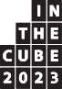
Exhibition (scheduled) ｜ Schedule (subject to change)

Exhibition (scheduled)

Schedule (subject to change)
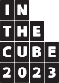
- Period
April 22 (Sat.) – June 18 (Sun.) 2023: Open for 50 days
- Venue
The Museum of Fine Arts, Gifu (4-1-22, Usa, Gifu City, Gifu Prefecture): Galleries
- Number of exhibits Approx. 14 works

- Reception of applications
December 24 (Fri.) 2021 to no later than 17:00, May 16 (Mon.) 2022
*If sent by post, the application must be postmarked by May 16, 2022.
After this period, in the process of selecting winners, applicants may be asked to submit additional materials and/or be interviewed. Applications received after the application period will not be accepted for any reason whatsoever.
- Preliminary selection Mid-June 2022
- Primary selection Early August 2022
- Announcement of the primary selection results Early September 2022
An applicant (hereafter, “Applicant”) passing the primary selection (hereafter, “Exhibitor”) will be announced on the official website of the Executive Committee of Gifu Land of Clear Waters Art Festival Art Award IN THE CUBE and/or Gifu Prefectural Government (hereafter, the “Host”). Applicants will also be notified of the result individually.
An Exhibitor and the Host will sign an agreement regarding the production of their work. Each Exhibitor who passes the primary selection will be awarded the prize money.
It is planned to provide technical counseling and support regarding the exhibition.
- Preliminary production of exhibits September 2022 – Late March 2023
The Host will have a discussion with Exhibitors regarding installation of their work. In the process of the discussion, the Host may ask Exhibitors to partially change their plans due to installation restrictions at the exhibition site and other factors.
During this period, the Host will receive installation-related and technical inquiries associated with the production of exhibits and will respond to them. Exhibitors’ inquiries and the Host’s responses to them may be made public on the official website.
- Installation of exhibits
Late March – Early April 2023
Exhibitors will be requested to work on their exhibits at the exhibition site.
Exhibitors may consult with the Host when they need assistance to install their work, such as staff and/or volunteers to help carry out the work within the venue and who can provide technical support.
- Secondary selection Early April 2023
- Announcement of the secondary selection results Mid-April 2023
Winners of the Grand Prize and Judges Prize(s) (each judge can award one prize) will be announced on the official website. Winners will be notified of the result individually.
- Exhibition period
April 22 (Sat.) – June 18 (Sun.) 2023: Open for 50 days

- Removal period of the exhibits
June 19 (Mon.) – June 22 (Thu.) 2023: Four days
Exhibitors are in principle required to remove their work by themselves. Cubicles will be removed by the Host. If it is difficult to separate the work from the cubicle, how to remove them will be discussed between the Exhibitor and the Host. The Exhibitor may be asked to remove the cubicle together with their work.

Selection

- Selection procedures
Preliminary selection: Mid-June 2022
The Art Award IN THE CUBE Planning Committee will assess the feasibility of each work in terms of safety, legal issues and other aspects.
Primary selection: Early August 2022
Judges will select winners of the primary stage (approx. 14 works).
Secondary selection: Early April 2023
Judges will select winners of the Grand Prize and Judges Prize(s).
During the period between the primary and secondary selections, proposals for award entries, information on the production process of artworks, interviews with Exhibitors, and other relevant information may be posted on the official website for publicity purposes.
- Judges (Names without honorifics)
IRIE Keiichi Architect and Design Director
IWASAKI Hideo Artist and Researcher / Professor, Faculty of Science and
Engineering, Waseda University, Director of metaPhorest KITAMURA Akiko Dancer and Choreographer / Professor, Faculty of Arts,
Shinshu University
SHIKATA Yukiko Curator and Critic
TERAUCHI Yoko Artist MORIMURA Yasumasa Artist
YAMAGIWA Juichi Director- General, Research Institute for Humanity and
Nature

- Prize money
Selection
Grand Prize (one work): ¥5 million (yen) Judges Prize: ¥1 million (yen)
Other selected works (approx. 14 works): ¥500,000 (yen) each
  - Winners of the Grand Prize and Judges Prize(s) will be selected from those who have passed the primary selection. There may be no winners for these prizes.
  - The amounts of prize money above include tax. The prize money for the winners of the Grand Prize and Judges Prize(s) will be given separately from the prize for those who have passed the primary selection.
(Income tax will be deducted from the prize money. To overseas winners, any tax treaty with the country where they reside may be applied.)
  - Ownership of the works of the Exhibitors shall not be transferred to the Host as a result of being given the prizes above.
  - The details of prizes and the amounts of prize money are subject to change in the event of disaster, social circumstances or other factors.
  - Each Exhibitor who passes the primary selection will be awarded the prize money.
  - After passing the primary selection, if an Exhibitor becomes unable to produce their work, or if the actual work significantly differs from the one described in the submitted plan, for whatever reason, the prize will be withdrawn and the Exhibitor must return the prize money immediately.
  - If more than one judge selects the same Exhibitor, the Exhibitor will still only be offered the prize money once.

Application regulations for the award

Application regulations for the award
- Application qualification
Those who understand the objective of Art Award IN THE CUBE 2023 and, if selected, will work on completing the production of their work in a responsible manner.
(Both individuals and groups, in any age group, of any nationality are eligible.)
- Theme
“REAL” no yukue (“Where ‘REALITY’ Goes”)
- Regulations for works to be submitted etc.
Works that have already been made public are not accepted. Only one work per individual or per group is accepted.
  - A work means an exhibit using a cubicle of the designated size.
  - An Applicant must hold all the rights to the work to be submitted. In addition, works that infringe on the copyrights, portrait rights, trademark rights, ownership rights, or other rights of third parties, such as using the work of someone other than the Applicant without permission, will not be accepted.
  - If copyrighted material, such as pieces of music, photos, and trademarks are used for the exhibition, the user must get approval for such copyrights and trademarks, in advance, by themselves.
  - In case of conflict between an Applicant and a third party, the Host will not assume any responsibility. The Applicant must resolve the conflict on their own and at their own expense. If conflict between an Applicant and a third party causes damage to the Host, the Applicant is liable for the entirety of any damages.
  - Works that violate laws and regulations and/or are against public order or morals will not be displayed.
  - Exhibits that do not conform to the aims and objectives of this project, such as those produced for profit-making as their main purpose, or produced as religious or political propaganda, may not be displayed.
  - Applicants are allowed to use external funding from companies and other sources and seek cooperation from companies. It is also permitted to display sources of cooperation within the cubicle or on the walls.
- Size and other requirements for a work to be submitted
A work to be submitted must be installed in a cubicle space, measuring 4.8 m (w) x 4.8 m (d) x 3.6 m (h) (decoration inside the cube and on the exterior walls).
  - See the floor plan (p.10).
  - The cubicle prepared by the Host is made of wood and has four sides, each of which measures 4.8 m (w) x 3.6 m (h), and a ceiling measuring 4.8 m (w) x 4.8 m (d). There is an opening in one of the walls, measuring 1.2 m (w) x 2.0 m (h).
  - It is possible to remove walls and the ceiling. If two or more walls are removed, a square steel pipe frame will be needed.
  - A wall can withstand a load of 20 kg/m2 and the ceiling can withstand a load of 3 kg/m2.
  - The floor of the museum can withstand a load of 1 t/m2.
  - Exhibitors are allowed to strengthen the durability of the cubicle itself, make changes to the cubicle (making a hole in a wall etc.) or make their own cubicle, only after consulting with the Host. As a general rule, the cost for the above must be borne by the Exhibitor.
  - While there is no restriction on the materials, shape and techniques for works to be displayed, works that may interfere with the management of facilities of the Museum of Fine Arts, Gifu, such as works containing organic matter, hazardous materials, materials that may emit a foul odor or decompose, or works that may be dangerous to display, install, or view, will not be displayed.
  - A work that generates sound, vibration and/or other effects is acceptable. If such a work affects other works, or if it interferes with the management of the facilities of the Museum of Fine Arts, Gifu, discussions may be held with the Host or other Exhibitors before exhibiting it.
  - The Host may ask Exhibitors to partially change their plan due to installation restrictions at the exhibition site. However, Applicants are allowed to make their initial proposal for their work without taking into account any installation restrictions; a discussion between Exhibitors and the Host on possible partial change will be held after the primary selection.
- Costs
Costs incurred by Applicants/Exhibitors

  - All costs incurred in association with a work to be submitted, such as the costs for application, production and transportation, and insurance fees
  - Personnel, travel, accommodation and other costs related to the delivery of a work into the venue, the installation, display, maintenance, repair and demolition of the work, the removal of the work from the venue, and meetings to discuss exhibition-related matters
  - Costs required for the Exhibitor to strengthen the durability of the cubicle, make some addition to the cubicle or make their own cubicle
  - Costs for lighting within the cubicle
  - Fees for using and transporting audio, video and other electronic equipment and devices that are not included in facilities auxiliary to the museum, and associated personnel expenses
  - Fees for copyrights, such as music or other copyrighted material
  - Fees for performers and their accommodation, and expenses for supplies
  - All costs other than those borne by the Host
Costs incurred by the Host
- Prize money (after deducting tax), expenses associated with the payment of the prize money (bank transfer fees etc.)
- Venue rental fees, rental fees for facilities attached to the venue
- Costs for basic lighting for the exhibition area (Lighting installed in the exhibition site)
- Costs for producing, dismantling and removing cubicles
- Costs for security staff at exhibition venues
- Insurance premiums to cover losses through theft of and/or damage to works during the exhibition period. (The purchase of a property insurance policy with an upper limit on coverage is being planned.)
- Costs of publicity materials regarding the overall exhibition, such as leaflets, posters and website operation; and costs of preparing archives, such as documentary photos, videos and documents
(Exhibitors will be asked to prepare some documents and provide photos and other materials for this purpose.)

How to apply for the award
Application regulations for the award ｜ How to apply for the award
- Documents and other materials required to be submitted
The materials listed in A and B below must be submitted in the designated file formats and must not exceed the designated capacity. Please note that materials that do not meet the requirements will not be accepted.
- Essential materials
(Use the forms located on pp.11–19, or download the formats from the official website.)
Application form (pp.11–12)
Fill in all the sections with information on the Applicant.
Proposal [1] (p.13)
Provide the title and shape of the work, materials used for the work, how it will be produced, a production schedule, expected grants or cooperation from other organizations and details, the form of the cubicle, the concept behind the work, and a brief explanation of the work.
Proposal [2] (p.15)
Provide an image of the work in any form, such as a sketch, a photo of a model of the work, or a computer graphic image of the work that clearly represents the work.
Proposal [3] (p.17)
Provide a three-view drawing of how the work will be when it is exhibited.
Proposal [4] (p.19)
If the exterior of the cubicle is modified as part of the work, provide information on the modification according to the instructions given in Proposal
[2]. (If no modification is made on the exterior, this proposal form is not necessary.)
  - Documents above must be written either in Japanese or English.
  - If proposals are submitted in an electronic data format. data attached to Proposals [2], [3] and [4] must be an image in JPG or PDF format, with a longitudinal length of ≥ 600 pixels, and no more than 3 megabytes. Application documents and proposals must be submitted in PDF format.
  - Application documents and Proposals [1], [2], [3] and [4] must be displayed in landscape orientation, A4 size, and must not change when they are printed.

How to apply for the award

  - With regard to three-view drawings, the Applicant can download PDF data from the website and design it using Illustrator or other drawing apps, and may then attach it to Proposal [3] as an image.
  - If the proposals [1] to [3] are not submitted, the work will be disqualified.
- Optional materials
Medium in which the entry is recorded
If the entry is in the form of performance or others that can only be displayed in the form of video or animation, submit a video recorded on a medium (DVD or BD) through which the Host can understand the content of the entry. (The file must be ≤ 500 megabytes in size.)
Image of a miniature (maquette)
If the procedure described in the Proposal is not enough to explain the work to enter, it is possible to use a miniature of the entry. If a miniature is submitted, Optional Material [1] (Image of a miniature) (p.21) attached with a photographed image of the miniature must be submitted.
Image of a work produced in the past
It is acceptable to submit an image of a work produced in the past as a reference material. In such a case, submit Optional Material [2] (Image of a work in the past) (p.23) attached with the image.
  - The size of a miniature must be within 1/10.
  - If Optional Material [1] or [2] is submitted in an electronic data format, data attached to the form must be an image in JPG or PDF format, with a longitudinal length of ≥ 600 pixels, not more than 3 megabytes. Optional Material itself must be submitted in PDF format.
  - The format of the video data shall be as follows:
Visuals: MOV, MP4 or WMV format (DVD: region code “2” or “ALL”; BD: region code “A” or “Free”)
- Documents/materials to be submitted in the categories A and B above
- If essential materials and optional materials are submitted as printed copy, they must be displayed in landscape orientation on A4 size, which must not change when they are printed.
- Proposals [1] to [4] and Optional Materials [1] and [2] should be submitted as one sheet each. If more than one sheet is submitted, only the first sheet will be accepted, and the second and subsequent sheets will not be considered.
- When attaching separate sheets as materials to Proposals [2] to [4] and Optional Materials [1] and [2], do not overlap and paste, or fold and paste, the sheets.
- Do not include anything that can identify the Applicant (such as Applicant’s or Applicant group’s name etc.) in Proposals [1], [2], [3] and [4] and Optional Materials [1] and [2], for the sake of selection.
- Materials to be submitted (application form, proposal, image of a miniature, image of a work produced in the past) may be used for the purpose of publicity of the award or other relevant promotional activities (brochures, websites, press releases, etc.) without any monetary compensation to the Applicant.
- The decision on whether to retain or discard materials to be submitted is left up to the Host and, as a rule, they will not be returned to the Applicant. Miniatures can be returned by cash on delivery. If Applicants do not require a miniature to be returned, please inform the Host.
- How to apply
Applications can be received through the official website or by post.
Follow the procedures below for each means. An Applicant may send by post a miniature of their entry and/or data recorded on a medium (DVD or BD), at their discretion. When sending such materials, attach the Forwarding Slip (p.27) to them.
*Postage fees must be borne by the Applicant.
- Official website
Send the Application Form after filling in all the necessary information.
Each file should not exceed 10 MB in size. Applicants will be authenticated by their email address before they can start registration on the application form. Proceed with the registration from the URL provided in the authentication email.
Once registered, Applicants cannot change their registration details. If they lose the URL to the application form, access the application form from the reminder email that will arrive in a few days.
Depending on email settings, the reception completion email from the application form may be placed in a different folder as spam or junk mail. Make sure to check your email settings.

- By post
Send essential and optional materials to the address below.
- Where to apply
- Official website https://art-award-gifu.jp/
- By post
Tokai Bldg. 3F, 9-16, Wakamiya-cho, Gifu City, Gifu Prefecture 500-8828
Application Reception Section, Secretariat of the Executive Committee, Gifu Land of Clear Waters Art Festival - Art Award IN THE CUBE
- Selection fee
¥5,000 (yen) per entry (tax included)
The screening fee will not be returned for any reason.
- If the payment is made by credit card, follow the procedure on the official website (https://art- award-gifu.jp/). Payment can only be made by credit card.
- Post
Please transfer the screening fee to the following bank account:
Terrasse Nayabashi Branch (038) Ogaki Kyoritsu Bank Savings Account No. 419959
Seiryu no kuni gifu geijyutsusai jimukyoku ohbo uketsukekakari kaikeitanto Kanda Makoto
  - The bank transfer fee must be borne by the Applicant.
  - The payer’s name must be the Applicant’s name.
  - The transfer transaction number, the payer’s name and other relevant information must be provided in the “Information on the payment of the screening fee” section of the application form.
- Inquiries and responses regarding the application
Inquiry reception period: December 10 (Fri.) 2021 – 17:00 April 22 (Fri.) 2022 Responses will be posted on the official website by April 26 (Tue.) 2022.
An Applicant may ask questions through the official website.
Other means will not be accepted. Please note that the Host will not respond to inquiries by phone or in person.
- Contact information for inquiries regarding the application
Application Reception Section, Secretariat of the Executive Committee, Gifu Land of Clear Waters Art Festival - Art Award IN THE CUBE
Tokai Bldg. 3F, 9-16, Wakamiya-cho, Gifu City, Gifu Prefecture 500-8828 Tel: 050-5526-5472
Inquiries are not accepted on Saturdays, Sundays, national holidays and New Year holidays. Telephone inquiries are accepted between 10:00 and 17:00.

Important points
How to apply for the award
- Issues related to rights, such as copyrights and proprietary rights
  - Copyrights of all works and application materials submitted (including performance entries and events) will belong to their authors.
  - Within the scope of the selection process of the Art Award IN THE CUBE, the Host will duplicate application materials.
  - Works selected in the primary selection process may be duplicated, screened, broadcast, made public online, displayed, translated or used for other purposes by the Host within the scope of the selection results announcement, exhibition, display and advertisement of subsequent series of the Art Award IN THE CUBE, without any monetary compensation to their authors.
  - Works to be exhibited and introduced at the exhibition will be recorded as videos, photos and/or in other forms, which may be used for the purpose of advertising the Art Award IN THE CUBE, provided to the media, or used for relevant projects. The Host will decide how and where to take videos and photos.

Important points

  - Visitors to the exhibition may take pictures of works for non-profit and private purposes, and to be used for public transmission and automatic public transmission (contributions to social media etc.) while they are being exhibited.
  - Applicants must ensure that their entry work does not violate any third-party rights and, if any complaint in this regard is received, they must address it at their own responsibility. If conflict between an Applicant and a third party causes damage to the Host, the Applicant is liable for the entire damage.
  - Images provided by Exhibitors for the purpose of publicity may be trimmed or otherwise processed by the Host when they are used.
  - The property rights of each work belong in principle to its author.
  - When entry works are presented and/or exhibited on other occasions, it must be clearly stated that they were produced on the occasion of Gifu Land of Clear Waters Art Festival - Art Award IN THE CUBE 2023.
- Issues related to the exhibition of works
  - The place where each cubicle is installed in the venue will be decided by the Host.
  - Works to be exhibited must be produced and installed in such a way as to withstand the exhibition period. If works are designed to be touched or operated, they must be able to withstand being touched and operated.
  - If a work is broken or damaged due to insufficient durability, its Exhibitor must repair it onsite at its own cost.
  - It is possible to make holes, use nails or modify the walls, ceiling and/or columns as long as such modifications do not affect the durability of the cubicle. It is, in principle, not permitted to modify the floor of the cubicle. However, if the Exhibitor takes measures to prevent damage to the facilities, such as preparing floor boards themselves, it is permissible to modify it.
  - Electrical wiring in the cubicle will be installed by the Host. Lighting equipment and accessories must be prepared by Exhibitors. The way in which electrical wiring will be installed will be determined after discussion between the Host and an Exhibitor.
  - The electrical power source available in the cubicle is 100 volts, 15 amps from one circuit. If higher voltages and amps are needed, the Exhibitor must discuss it with the Host. (It is not permitted to install electrical equipment for which the Exhibitor needs to draw electricity from an external source, such as a generator installed outside of the venue, or one that exhausts any gas in the venue.)
  - If an entry is in the form of video, the Exhibitor must prepare, if necessary, devices to play it, such as a projector, PC, DVD player, speaker and/or blackout curtains, by him/herself.
  - In the venue, cubicles adjoin each other. The Exhibitors should be aware that work may be affected by sound, vibration and light from other works.
  - If an entry is in the form of performing art, which cannot be displayed continuously, perform it several times during the exhibition period. (Associated accommodation and other costs must be borne by the Exhibitor.) During other times, place something that provides information on the details of the performance.
  - The Host can perform simple turning on and off of a switch but, in principle, does not operate or manipulate devices and equipment other than in an emergency.
  - After the exhibition, the cubicle itself will in principle be removed by the Host. If the work and the cubicle are not separable, it is possible for the Exhibitor to take it out of the venue after discussing with the Host. In this case, transportation costs must be borne by the Exhibitor.
  - Insurance premiums to cover losses through theft of and/or damage to works during the exhibition period will be borne by the Host. (The purchase of a property insurance policy with an upper limit on coverage is being planned.)
  - The Host will take great care in exhibiting and handling entry works but will assume no responsibility for any damage caused by natural disasters and other contingencies.
  - In the exhibition space, no commercial transactions and no advertising and publicity for commercial purposes are permitted. However, it is allowed to display the logos and names of cooperating companies on the inside of the cubicle and the walls.
  - Exhibitors must remove their exhibit and deal with waste on their own responsibility, at their expense.

- Other important points
  - Exhibitors who pass the primary screening will be required to sign an agreement separately.
  - Exhibitors will be requested to attend events designated by the Host, such as the award ceremony.
  - Exhibitors may be asked to provide additional materials in the screening process.
  - If there are any defects or false statements in the application, documents and materials submitted, or if any violation of regulations, agreements or other problems occurs, the selection/award will be withdrawn and the winner will be asked to return any prize money already paid immediately.
  - Any inquiries about the progress of the selection of entries, or inquiries about reasons for the selection will not be accepted.
  - The Host will not make any compensation for damage and loss caused during the delivery of a work.
  - Important information regarding the “Art Festival in Gifu, Land of Clear Waters - Art Award IN THE CUBE 2023” (e.g. in case of any change in date, time and venue due to social circumstances or other reasons) will be posted on the official website (https://art- award-gifu.jp/).
  - In case of a conflict between the Host and an Applicant, Japanese law will apply and the Gifu District Court will serve as the dedicated competent court of the first trial.
  - Any matters not stipulated in this guideline shall be determined on a case-by-case basis upon consultation between the Applicant and the Host.

Handling of personal information
Important points ｜ Handling of personal information
The Executive Committee of the Gifu Land of Clear Waters - Art Festival Art Award IN THE CUBE defines its role in protecting Applicants’ personal information as described below. In compliance with this definition, the Host will take all possible care to prevent personal information from leaking, use for any other purpose, alteration or otherwise.
- Purposes of use of personal information
Applicants’ personal information will only be used for the limited scope purposes described below:
  - Notification of selection results
  - Communication to confirm entry-related information and questions
  - Statistical analysis with the aim of improving the Art Award IN THE CUBE
  - Provision of information related to the Art Award IN THE CUBE, such as exhibitions and invitations to apply for the award
(These pieces of information will not be provided upon request.)
  - Publication of a list of winners in mass media and on the website
(Work titles, winners’ names and affiliations, etc. Whatever is to be disclosed will be notified to the individual concerned in advance.)
If such information needs to be disclosed for purposes other than those above, we will obtain the consent of the individual concerned in advance.
- Disclosure and communication to third parties
  - Applicants’ personal information will be managed and protected in an appropriate manner.
  - Applicants’ personal information will not be disclosed and communicated to third parties without their consent. However, such information may be disclosed to subcontractors only when it is necessary to hold the Art Award IN THE CUBE and carry out the activities of the AAIC Secretariat.
The above does not apply in cases in which disclosure is necessary for the protection of life, body or property and in which it is difficult to obtain the consent of the individual concerned, or cases in which disclosure is required by law.
- Applicants’ consent
  - An Applicant must confirm the points specified in (1) and (2) above before filing an application.
  - Upon receiving an application form, it will be understood that we have obtained the consent of the Applicant and author.
ii. Others
In some cases, applicants may be requested to submit necessary documents regarding the handling of personal information.

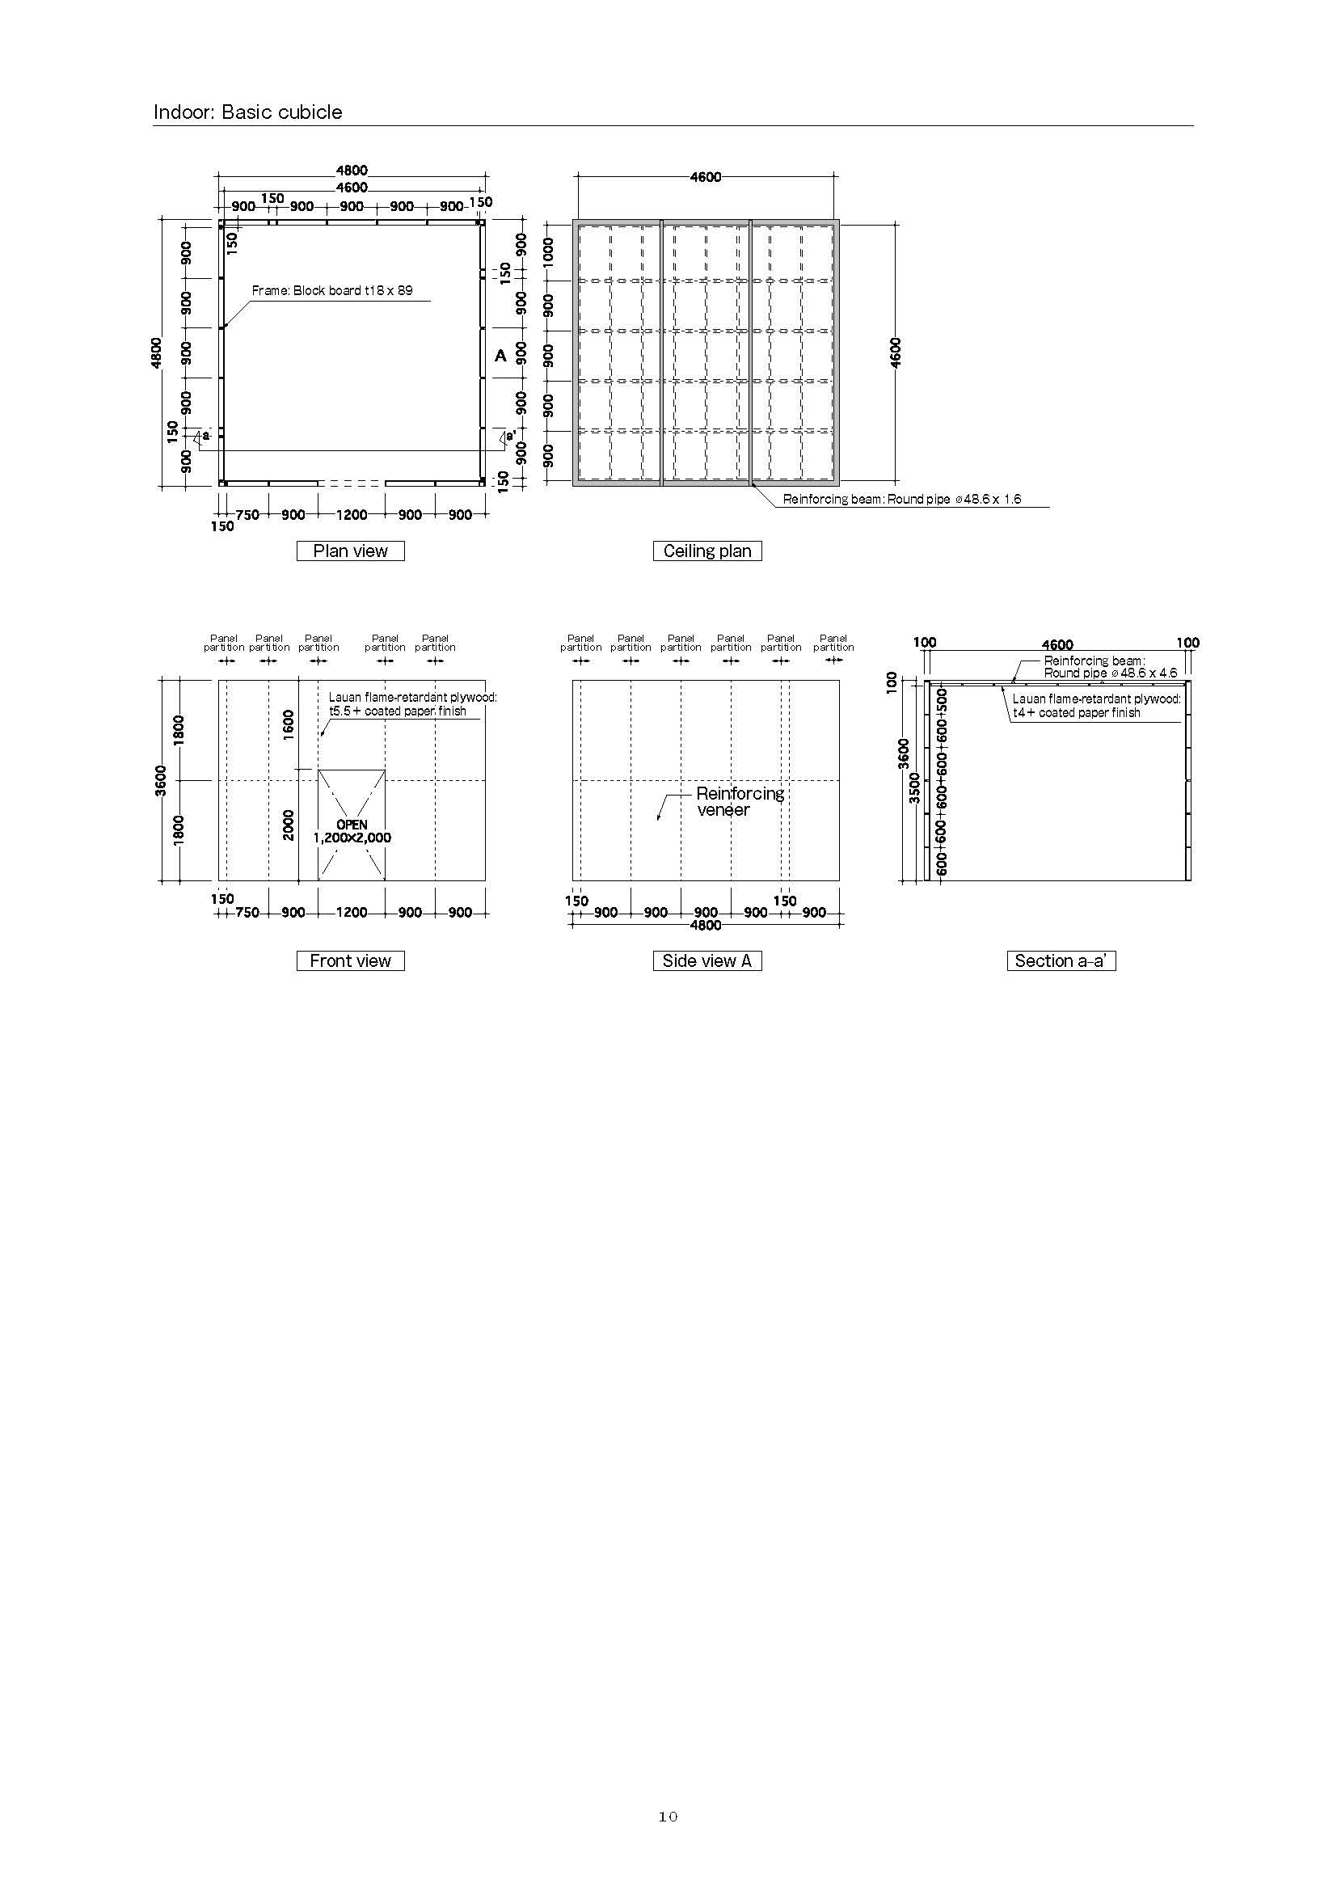
Gifu Land of Clear Waters Art Festival

Application Form (front)
Application period
Dec 24 (Fri.), 2021–May 16 (Mon.), 2022
For AAIC
Secretariat use only

11

This application form can also be submitted from the official website. *Upon receipt by the AAIC, the Applicant is deemed to have consented to the requirements rules and procedures described in the Invitation for Participation.

Individual or group name |  | Pen name |  | Representative name
Title of the work

(If the Applicant is a group of individuals, please provide information on the representative person in the sections below.)
Age/Gender | (as of 2022/1/1)  years old | （Date of birth）  year month date |  |  | Gender (Check the one that applies to you. You may leave this box blank.) |  | Male |  | Female
Birthplace (Country/Prefecture)
Present address | Postal code
Contact information (Telephone No. etc.) | (Home phone) |  |  | (Fax)
 | (Mobile phone) |  |  | (Email)
Personal history/Brief summary of activities | (Provide brief descriptions that can be made public. Put ◎ before items in your personal/activity history that you want to be included in a digest version of your profile (in approx. 30 to 40 words) to be shown  in a list of works.)
Major exhibitions and awards | List up to five exhibitions that you have participated in and awards that you have received. [Example] Exhibitions: year, exhibition name (Clarify whether solo of group), venue, city; Awards: year, award’s name (e.g. Grand Prize of the xxx Contest), city
１.
２.
３.
４.
５.

Gifu Land of Clear Waters Art Festival

Application Form (back)
Application period
Dec 24 (Fri.), 2021–May 16 (Mon.), 2022
For AAIC
Secretariat use only

Information on payment of the selection fee
Sender’s name
Transfer date and time
Name of bank
Handling No./Receipt No.

You may attach a copy of the transfer statement of the screening fee instead of filling in this section.

Questions (Please answer the following questions as far as possible – they will not affect the decisions for selection.)

Q1. How did you learn about AAIC2023? (Multiple choices allowed)
12
Magazine |  | Bijutsu Techo |  | Geijyutsu Shincho |  | Other ( )
Internet |  | Official website |  | ART iT |  | SHIFT |  | Online public invitation guide |  | Toryumon
 |  | Facebook |  | Twitter |  | Instagram |  | Other ( )
Printed media (Place where you got it) |  | School |  | Art museum |  | Gallery |  | Cultural center |  | Event
 | Other ( )
Other ( )

Q2. What is your reason for applying for AAIC2023? (Multiple choices allowed)
 | The prize money |  | The judges |  | The fact that AAIC2023 is open to anyone |  | The concept of the AAIC2023 |  | The chance to exhibit my work in the museum
Other ( )

Q3. Please feel free to write any comments below

Gifu Land of Clear Waters Art Festival

Proposal [1] (Information on the work)
Application period
Dec 24 (Fri.), 2021–May 16 (Mon.), 2022
For AAIC
Secretariat use only

13

Title of the work

Shape/Form |  | Plane surface |  | Three-dimensional work |  | video |  | Installation |  | Others（ ）

Materials used How to produce
Production schedule*1

Cubicle (Select one and put ○ in front of the selected place) |  | Without modifications (4 walls and ceiling) |  | With modifications (including removal of the ceiling) |  | Cubicle not necessary  (including production of a cubicle by the Applicant)

Concept of the work (in not more than 250 words)

Brief explanation of the work (in not more than 50 words)*2
*Information described in *1 to *2 provided by Applicants passing the primary selection may be used in a list of works, collection of records, etc. *Please submit a single sheet of A4 size of landscape orientation. (Do not change the size or orientation of the form. The second and subsequent pages will not be screened.)
Note: For screening purposes, please do not include any information that could identify the Applicant (name of Applicant/group, etc.) in this form.

14

Gifu Land of Clear Waters Art Festival

Proposal [2] (Image of the work)
Application period
Dec 24 (Fri.), 2021–May 16 (Mon.), 2022
For AAIC
Secretariat use only

15

*Provide a clear image of the work. For example, you may provide an idea sketch or attach a photo of the work. *The submitted image of a work selected in the primary selection may be used in a list of works, collection of records, etc.
*Please submit a single sheet of A4 size of landscape orientation. (Do not change the size or orientation of the form. The second and subsequent pages will not be screened.)
Note: For screening purposes, please do not include any information that could identify the Applicant (name of Applicant/group, etc.) in this form.

16

Gifu Land of Clear Waters Art Festival

Proposal [3] (Three-view drawing)
Application period
Dec 24 (Fri.), 2021–May 16 (Mon.), 2022
For AAIC
Secretariat use only

Inside measurement (width) 4,600 mm

Scale 1：60
*These measurements are approximate.
The actual cubicle will have walls and a ceiling. (This is a translucent display.)
The inside measurement is the size between columns.

Plan
17
Inside measurement (depth) 4,600 mm

Front view Side view
Inside measurement (height) 3,500 mm

*Please submit a single sheet of A4 size of landscape orientation. (Do not change the size or orientation of the form. The second and subsequent pages will not be screened.) Note: For screening purposes, please do not include any information that could identify the Applicant (name of Applicant/group, etc.) in this form.

18

Gifu Land of Clear Waters Art Festival

Proposal [4]

( M o d i f i c a t io n t o th e exterior of the cubicle)
Application period
Dec 24 (Fri.), 2021–May 16 (Mon.), 2022
For AAIC
Secretariat use only

19

Provide an image of modification to the exterior of the cubicle, if any. For example, you may provide an idea sketch or attach a photo of the work.
*Please submit a single sheet of A4 size of landscape orientation. (Do not change the size or orientation of the form. The second and subsequent pages will not be screened.)
Note: For screening purposes, please do not include any information that could identify the Applicant (name of Applicant/group, etc.) in this form.

20

Gifu Land of Clear Waters Art Festival
miniature)

Optional Material [1] ( Image of a
Application period
Dec 24 (Fri.), 2021–May 16 (Mon.), 2022
For AAIC
Secretariat use only

21

*Attach photographed image(s) of the miniature to this form. Please submit a single sheet of A4 size of landscape orientation. (Do not change the size or orientation of the form. The second and subsequent pages will not be screened.)

Note: For screening purposes, please do not include any information that could identify the Applicant (name of Applicant/group, etc.) in this form.

22

Gifu Land of Clear Waters Art Festival
previous work)

Optional Material [2] ( I m a g e o f a
Application period
Dec 24 (Fri.), 2021–May 16 (Mon.), 2022
For AAIC
Secretariat use only

23

*Attach image(s) of a work produced in the past to this form. Please submit a single sheet of A4 size of landscape orientation. (Do not change the size or orientation of the form. The second and subsequent pages will not be screened.)

Note: For screening purposes, please do not include any information that could identify the Applicant (name of Applicant/group, etc.) in this form.

24

Gifu Land of Clear Waters Art Festival

Inquiry Sheet

Please fill in all the fields below and send it from the official website
25
Inquirer’s name
Phone number or email address*

Inquiry

Inquiry

Inquiry

*This information will not be used for any purpose other than to confirm the meaning of the question and relevant matters.

Contact information ｜ Application Reception Section, Secretariat of the Executive Committee, Gifu Land of Clear Waters Art Festival – Art Award IN THE CUBE URL: https://art-award-gifu.jp/

26

Gifu Land of Clear Waters Art Festival

Forwarding Sheet

Cut line

Use this sheet when sending materials for selection by post.t
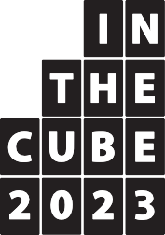
Cut line

〒500 -8828
Tokai Bldg. 3F, 9-16, Wakamiya-cho, Gifu City,
Gifu Prefecture
Application Reception Section Secretariat of the Executive Committee Gifu Land of Clear Waters Art Festival – Art Award IN THE CUBE

Attach the form below to the rear side of the miniature or the surface of the DVD or BD case.
Cut line
27

Name
Title of the work

Name
Title of the work

